### 1.4.5 Skin whitening

Picture whitening formula:

**p = P*1.4(a)+ b**

Code:

|  |
| --- |
| import cv2  import numpy as np  import matplotlib.pyplot as plt  img = cv2.imread('image0.jpg',1)  imgInfo = img.shape  height = imgInfo[0]  width = imgInfo[1]  #cv2.imshow('src',img)  dst = np.zeros((height,width,3),np.uint8)  for i in range(0,height):  for j in range(0,width):  (b,g,r) = img[i,j]  bb = int(b*1.3) + 10  gg = int(g*1.2) + 15  if bb>255:  bb = 255  if gg>255:  gg = 255  dst[i,j] = (bb,gg,r)  # cv2.imshow('dst',dst)  # cv2.waitKey(0)  img = cv2.cvtColor(img, cv2.COLOR_BGR2RGB)  dst = cv2.cvtColor(dst, cv2.COLOR_BGR2RGB)  plt.figure(figsize=(14, 6), dpi=100) # Set the size and pixels of the drawing area  plt.subplot(121) # The first in a row and two columns  plt.imshow(img)  plt.subplot(122) # The second in a row and two columns  plt.imshow(dst)  plt.show() |

After running the above program, two pictures will be displayed in the jupyterLab control interface, as shown below.

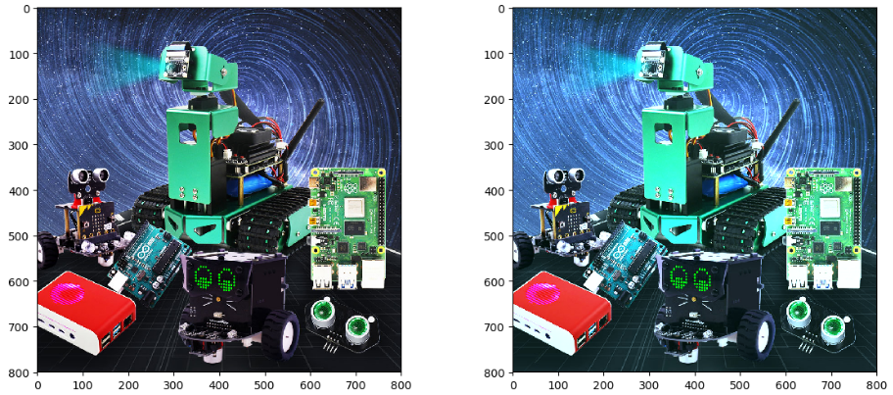

**[Original picture] [Skin whitening picture]**

Bilateral filtering is a nonlinear filtering method. This method can only filter out low-frequency information better.

The code is as follows,

|  |
| --- |
| import cv2  import matplotlib.pyplot as plt  img = cv2.imread('yahboom.jpg',1)  #cv2.imshow('src',img)  dst = cv2.bilateralFilter(img,15,35,35)  # cv2.imshow('dst',dst)  # cv2.waitKey(0)  img = cv2.cvtColor(img, cv2.COLOR_BGR2RGB)  dst = cv2.cvtColor(dst, cv2.COLOR_BGR2RGB)  plt.figure(figsize=(14, 6), dpi=100) # Set the size and pixels of the drawing area  plt.subplot(121) # The first in a row and two columns  plt.imshow(img)  plt.subplot(122) # The second in a row and two columns  plt.imshow(dst)  plt.show() |

After running the above program, two pictures will be displayed in the jupyterLab control interface, as shown below.

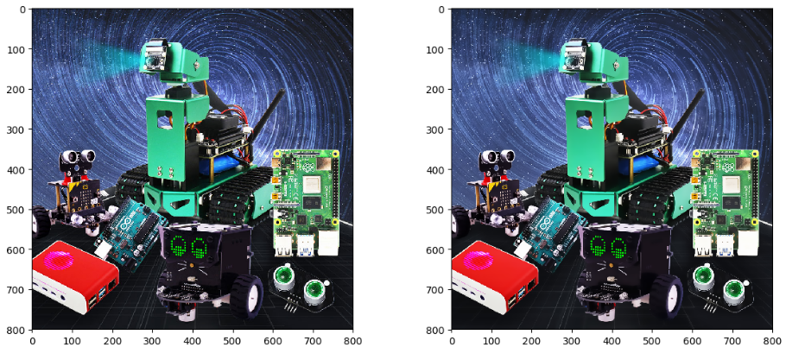

**[Original picture] [Skin whitening picture]**